Towards AI-Assisted Vocational Curriculum Design: Bridging Future-Aware Job Market Demands and Education
Listyanti Dewi Astuti
Department of Software and Game Development, State Vocational High School 12 of Malang

__________________________________________________________

Abstract
Vocational education faces a pressing need to keep pace with rapidly evolving job market demands. This paper proposes a novel AI-assisted curriculum design framework that dynamically aligns educational content with future-aware labor market skills. Our approach combines natural language processing (NLP) and large language models (LLMs) in a modular pipeline to extract in-demand skills from job postings, prioritize those skills using trend forecasts, and generate a competency-based curriculum framework mapped to Bloom’s taxonomy. We leverage a hybrid JobBERT+CRF model to extract hard, soft, and domain-specific knowledge skills from job descriptions, then employ GPT-4 for validation and refinement of these skill sets. By integrating external trend data – notably the World Economic Forum’s future skills reports and McKinsey’s workforce forecasts – we assign a future relevance weight to each skill cluster, ensuring our recommendations prioritize emerging competencies. The extracted skills are clustered into proposed competencies, for which we automatically generate descriptions and suggested Bloom’s cognitive levels for learning outcomes. We introduce a confidence-weighted coverage metric to assess how well the current curriculum covers each proposed competency, identifying gaps where demanded skills are underrepresented. An interactive expert review interface allows educators to validate and refine the AI-generated competency proposals. We validate the skill extraction module against benchmark datasets, achieving performance on par with state-of-the-art models (span-level F1 ≈ 0.60–0.65), and illustrate the framework’s utility with a case study in a software development vocational program. The results demonstrate that our AI-assisted approach can highlight misalignments between curricula and industry needs – for example, clusters of high-demand skills not yet covered in courses – and suggest updates to better prepare students for future jobs. This work contributes a practical methodology for dynamically updating vocational curricula, bridging the gap between education and employment through AI-driven insights while preserving pedagogical rigor.
Keywords: Curriculum design; Skill extraction; Labor market analysis; Future skills; Bloom’s taxonomy; Artificial intelligence in education
_____________________________________________________________________________

Introduction
Rapid technological and industrial changes are continually reshaping workforce skill demands, while educational institutions—particularly in vocational and technical domains—often struggle to update curricula at a comparable pace. Traditional curriculum development processes, which rely on infrequent industry input and lengthy review cycles, are increasingly unable to respond to the rapidly evolving requirements of the digital economy (Zhai et al., 2021). This misalignment contributes to widening skill gaps, leaving graduates inadequately prepared for contemporary labor market needs (Chen et al., 2020; Zhai et al., 2021). The World Economic Forum projects that 44% of core job skills will change by 2027, with rising demand for technological competencies such as AI and big data alongside human-centric skills including leadership and social influence. Complementing this, McKinsey estimates that by 2030 time spent on advanced technological skills will increase by approximately 50%, with programming and IT skills growing by up to 90%, while higher-order cognitive skills such as creativity and complex problem-solving become increasingly critical. Collectively, these trends highlight the urgent need for curricula that are more adaptive, future-oriented, and closely aligned with evolving industry competencies.
Artificial intelligence (AI) offers a promising avenue to address this challenge. Recent work suggests that AI can assist curriculum planners in forecasting future skill needs and personalizing learning pathways. In particular, advances in NLP enable automated analysis of labor market data – such as online job postings and industry reports – to identify in-demand skills and emerging trends (Chassignol et al., 2018; Tamburri et al., 2020). AI-driven analytics have the potential to continuously update curriculum content to reflect changing industry standards (Hwang et al., 2020). However, effectively integrating these insights into practical curriculum design remains a complex task. Challenges include extracting reliable skill information from noisy textual data, prioritizing which skills deserve curricular emphasis, and translating lists of skills into teachable competencies and learning outcomes. Moreover, any AI-generated recommendations must be scrutinized by human experts to ensure pedagogical relevance and feasibility in an academic context.
This paper presents a novel framework that leverages AI – specifically a combination of Hybrid NLP models and LLMs – to bridge the gap between future-aware job market demands and vocational education curricula. Our approach centers on a modular pipeline that (1) extracts and verifies labor market skills from job postings using a domain-trained BERT-based model with a Conditional Random Field (CRF) sequence tagger augmented by GPT-based validation, (2) performs future-aware skill prioritization by incorporating external trend data (e.g. World Economic Forum and McKinsey reports) and dynamic embedding techniques to weight skills according to their projected growth or decline, (3) generates a competency framework by clustering related skills and mapping them to course-level learning outcomes, including assigning Bloom’s taxonomy levels to each outcome, and (4) produces a confidence-weighted curriculum coverage analysis that quantifies how well the existing curriculum covers the in-demand skills, highlighting gaps and redundancies. An interactive expert review interface then enables curriculum developers and industry partners to review the AI-generated competency proposals, adjust mappings, and validate the recommendations before implementation.
Through an evaluation on real curriculum and job market data in the software development domain, we demonstrate that our approach can identify critical skill gaps and suggest pertinent additions to the curriculum. We also show that our skill extraction model achieves performance comparable to state-of-the-art systems on benchmark data (with an F1 score around 0.62 on a span-level skill extraction task, aligning with prior research), while our trend-weighting mechanism successfully distinguishes growing vs. declining skill areas. The resulting AI-assisted curriculum design offers a proactive blueprint for educational institutions to ensure graduates are equipped with the competencies needed for the future workforce. We argue that this methodology can significantly shorten the feedback loop between industry changes and curriculum updates, thereby bridging the gap between education and employment in a sustainable, data-informed manner.
The remainder of this paper is organized as follows. Section 2 reviews related work in AI-driven curriculum design and skill extraction. Section 3 details the proposed methodology, including the data sources, skill extraction and validation modules, future-aware weighting, and competency framework generation.
Section 4 presents the experimental results, including skill extraction performance and a case study of applying the framework to an existing curriculum, with analysis of the identified gaps and recommendations. Section 5 discusses the implications for curriculum developers, potential limitations, and future improvements. Finally, Section 6 concludes the paper with a summary of findings and the envisioned impact of AI-assisted curriculum design on vocational education.

Background and Related Work
Aligning curricula with industry requirements is a longstanding objective in vocational education. Traditional approaches have involved periodic industry advisory boards, employer surveys, and competency standard frameworks to guide curriculum updates. Research demonstrates that successful vocational programs explicitly map curriculum outcomes to industry competency standards and involve continuous industry collaboration. Nonetheless, keeping curricula up-to-date is challenging when the industry is rapidly evolving. For instance, digital transformation and automation are introducing new skill requirements at an unprecedented pace, leading to calls for more dynamic curriculum design processes. Recent literature reviews (e.g. Zhai et al., 2021) highlight the need for data-driven methods to make curricula more responsive to labor market changes, including the use of predictive analytics and NLP to identify emerging skills (Chen et al., 2020; Zhai et al., 2021). AI in education research has progressively moved toward integrating learning analytics, intelligent tutoring, and now curriculum analytics – using AI to inform what should be taught (Roll & Wylie, 2016; Hwang et al., 2020). Our work situates itself at this intersection of AI and curriculum design, extending prior efforts by focusing explicitly on future job market alignment in the context of vocational training.

2.1 Skill Extraction from Job Postings
The proliferation of online job postings has opened opportunities to mine these texts for required skills and competencies. A number of NLP approaches have been proposed to automatically extract skills from job advertisements and resumes (see SkillSense and related systems). Early methods relied on keyword matching against predefined skill dictionaries (e.g., ONET skill lists), but these are brittle and miss new expressions. More recent approaches frame skill extraction as a Named Entity Recognition (NER) or span detection task on unstructured text. For example, SkillSpan (Zhang et al., 2022) introduced an annotated dataset of 14.5K sentences from job postings with span labels for hard and soft skills, enabling supervised training of skill extraction models. Transformer-based models fine-tuned on such data have achieved strong results; a domain-adapted BERT model called JobBERT obtained a span-level F1 of ~60.3 on the SkillSpan benchmark, outperforming generic BERT.
Researchers have also explored multi-task learning to jointly extract skills and related attributes like knowledge areas (Zhang et al., 2022) and found that domain-specific pretraining boosts performance. To further improve sequence labeling consistency, many works add a CRF decoding layer on top of BERT, which can enforce valid tag sequences (e.g., no Illegal B–I tag orders). Empirical studies show that BERT+CRF models often achieve equal or better F1 than BERT with a softmax, while eliminating inconsistent labels. Our pipeline builds on this body of work by using a BERT-CRF model trained for skill extraction. We also address a gap in prior art by leveraging an LLM (GPT-4) to validate and enhance the raw predictions. Hybridizing a fine-tuned model’s output with LLM reasoning is relatively new; however, preliminary evidence suggests that GPT-3.5/4 can match or exceed fine-tuned models on certain extraction tasks when properly prompted (Greaves, 2023). Instead of replacing the domain model, we use GPT to supplement it – for instance, confirming whether an extracted phrase truly represents a skill or merging overlapping skill spans – thereby harnessing both approaches’ strengths.

2.2 Labor Market Forecasts and Future Skills
A distinctive aspect of our approach is incorporating future-oriented skill importance. We draw on official foresight reports and trend analyses to guide curriculum focus. The World Economic Forum’s periodic Future of Jobs reports and similar studies serve as high-level inputs on emerging skills. For example, the WEF 2020 report identified critical thinking, problem-solving, active learning, resilience, and flexibility as top growing skills through 2025. These reports also note that employers anticipate needing significant reskilling of workers (around 50% by 2025) to meet the demands of automation and AI adoption. In parallel, industry research by McKinsey and others provides quantitative projections on skill shifts. McKinsey’s analysis (Bughin et al., 2018) shows that by 2030, demand for advanced IT skills and programming in the U.S. could grow by nearly 90%, while basic data entry skills will decline sharply.
Likewise, social and emotional skills (e.g. communication, leadership) are expected to see ~20–30% increased demand due to their complementarity with technology. We use such insights to weight the skills extracted from data – an approach related to occupational forecasting. Prior works have attempted to predict future skill requirements using time-series analysis of job postings (e.g., growth in mentions of cloud computing over years) or by mapping occupations to at-risk-of-automation categories (Frey & Osborne, 2017). Our contribution is to integrate these external signals directly into curriculum design: rather than designing for the present state of the job market, we aim to future-proof the curriculum. To our knowledge, this explicit linkage of trend data (WEF, McKinsey) with automated curriculum recommendations has not been previously explored in the literature.

2.3 Competency Frameworks and Bloom’s Taxonomy
Competency-based education emphasizes defining what a learner should be able to do in demonstrable terms. In vocational education, curricula are often structured around competencies or learning outcomes tied to industry standards. We leverage this paradigm by aggregating skills into higher-level competencies. Each competency encompasses a set of related skills and knowledge that collectively enable a professional task or role (for example, a competency “Data Analysis and Problem Solving” might include skills in using data tools, statistical reasoning, and problem-solving strategies). Traditional development of competency frameworks is manual and time-intensive; experts convene to decide on competency titles, descriptions, and performance criteria. Our approach accelerates this by using AI to draft competencies automatically from labor market skill clusters.
We also map each competency to Bloom’s taxonomy, which classifies cognitive learning objectives in levels from lower-order to higher-order thinking (Remember, Understand, Apply, Analyze, Evaluate, Create) (Bloom, 1956; Anderson & Krathwohl, 2001). Bloom’s taxonomy is widely used in curriculum design to ensure that learning outcomes target appropriate cognitive complexity and that a program includes a progression from foundational knowledge to advanced skills. There have been efforts to use text mining to classify educational objectives into Bloom levels (e.g., using keywords or machine learning on outcome statements). In our work, we similarly analyze the action verbs and context of existing course outcomes to assign Bloom levels, and we suggest outcomes for new competencies with Bloom levels in mind. By doing so, we not only identify what new content is needed, but also how it might be taught (for instance, recommending that a new competency in “AI Programming” include an outcome at the Create level such as “Develop a simple AI application in Python,” not just at the Understand level). The inclusion of Bloom’s taxonomy and coverage analysis extends prior AI-driven curriculum tools (which might focus purely on content topics) to consider pedagogical depth and rigor.
In summary, our framework synthesizes techniques from several research threads – NLP-based skill extraction, labor market trend analysis, and automated curriculum mapping – to produce a comprehensive solution for curriculum updating. Next, we describe the design and implementation of this framework in detail.

Methodology
Our proposed system is a modular pipeline that processes labor market data and curriculum data to generate future-aligned curriculum recommendations. Figure 1 provides an overview of the pipeline architecture, which consists of four main stages: (1) Data Collection and Processing, (2) Skill Extraction and Verification, (3) Skill Clustering and Future Weighting, and (4) Competency Framework Generation and Mapping. In the following subsections, we describe each stage, including the models, algorithms, and data sources used. Our case study implementation focuses on a software development vocational program, but the methodology is domain-agnostic and can be applied to other fields by changing the input data.

3.1 Data Collection and Processing
The first stage involves gathering the relevant textual data from both the demand side (job market) and the supply side (educational curriculum):
- Job Postings Dataset: We collected a dataset of job postings relevant to the target field (software development, in our case) from online job boards and company career pages. The dataset comprised approximately 5,000 job advertisements for roles such as software developer, software engineer, web developer, and related positions. Each job posting typically includes a job title, a description of responsibilities, and a list of required or preferred qualifications and skills. We preprocessed the postings by removing irrelevant sections (e.g., company boilerplate descriptions) and splitting the text into sentences. Domain-specific terminologies (programming languages, frameworks, etc.) were preserved. We also tagged each posting with meta-data such as job role, industry, and publication date when available. This allowed analysis of skill trends over time and differences across sub-domains (e.g., data science vs. web development roles). The postings spanned the last 3 years, providing a recent snapshot of skill demands with some historical depth for trend analysis.

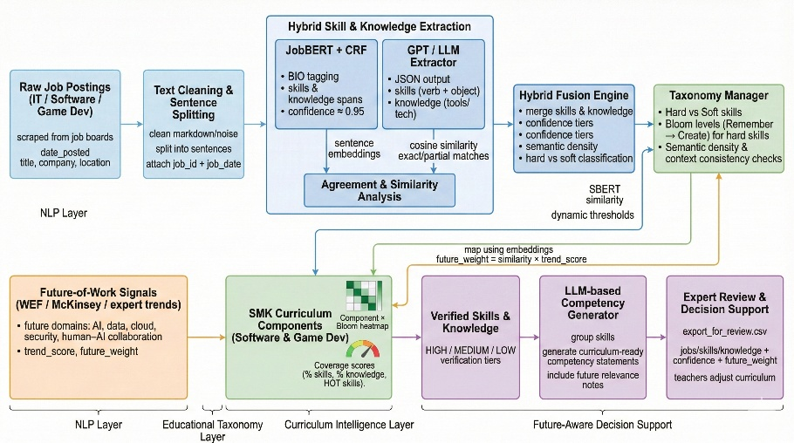
Figure 1. Overview of the AI-assisted curriculum design pipeline. The system ingests job postings and curriculum documents, extracts skill entities (using a BERT-CRF model), verifies them with an LLM (GPT), clusters skills into competencies, applies future trend weights, and maps them onto the current curriculum structure with Bloom’s taxonomy tagging. The outputs include a set of proposed competencies with associated skills and learning outcomes, a coverage analysis of the current curriculum (identifying gaps where in-demand skills are not covered), and an expert review interface for validation.
- Curriculum Documents: From the educational institution, we obtained curriculum documentation for the software development program. This included the program learning outcomes, course syllabi with detailed module descriptions, lists of topics covered, and specific learning outcomes or objectives for each course. These learning outcomes are typically sentence-form statements (e.g., “Students will be able to implement basic algorithms in Python”) often written by instructors following Bloom’s taxonomy guidelines. We parsed these documents to extract all the explicit skill statements and topics that are currently taught. Each course outline was segmented into its stated learning outcomes and any mention of required skills or tools. We assume this curriculum represents the current state which we aim to compare against job market needs. The curriculum data was also annotated by us (or by domain experts) with the Bloom level of each learning outcome (where available) for validation of our automated Bloom classification later. In our case study, the program consisted of 10 courses covering fundamentals of programming, web development, databases, etc., with a total of 60+ learning outcomes across all courses.
- External Skill Trend Data: In addition to raw text, we compiled auxiliary data from reports and databases to inform the future weighting. Key sources included: (a) the World Economic Forum’s Future of Jobs 2024 report and Future of Jobs 2025 update, which list trending skills and expected shifts by 2029 and 2030 respectively, (b) industry research papers (e.g., McKinsey Global Institute’s report on automation and skill shifts), and (c) historical labor market data – for instance, counts of job postings requiring certain skills year-over-year (we used an open dataset of tech job postings from 2018–2022). From these, we distilled a dictionary of skills with indicators such as “appears in WEF top 10 skills list” or “growth in demand +X% over Y years”. This external knowledge base is used in the weighting stage described later.
All textual data from job postings and curriculum were lowercased and tokenized for analysis. We made use of pre-trained word embeddings (specifically, a domain-tuned FastText embedding for job postings) to support clustering, as detailed below. The overall data processing pipeline was implemented in Python using libraries such as spaCy for text preprocessing and HuggingFace’s Transformers for model implementation.

3.2 Skill Extraction and Verification
The core of our pipeline is the Skill Extraction module, which scans job posting texts to identify spans that correspond to skills or competencies. We define “skills” broadly to include not only technical skills (e.g., Python programming, version control with Git), but also soft skills (e.g., communication, problem-solving) and domain-specific knowledge areas (e.g., software design principles). We adopt a Named Entity Recognition (NER) approach to this task, labeling each token in the job posting text as either part of a skill phrase or not. Our solution comprises two components working in tandem: a fine-tuned BERT-CRF model and an LLM-based verifier.
3.2.1. BERT-CRF Skill Tagger
We fine-tuned a BERT-based model that has been domain-adapted to job postings (JobBERT) to serve as our primary skill extractor. The model architecture is a BERT-base encoder whose token-level representations feed into a Conditional Random Field layer that produces the optimal tag sequence. We use the standard BIO tagging scheme where, for each token, the model predicts B-Skill (beginning of a skill phrase), I-Skill (inside a skill phrase), or O (outside skill). During training, the CRF considers transition probabilities to ensure legal sequences (e.g., I-Skill must follow B-Skill or I-Skill). We initialized the model from a version of BERT that had been further pre-trained on a large corpus of job postings (3 million sentences from a job ads dataset), similar to the approach of Zhang et al. (2022) and others. This domain-adaptive pre-training is shown to improve modeling of job text nuances (e.g., “agile” could mean Agile methodology). We then fine-tuned on labeled data: we utilized the SkillSpan dataset (Zhang et al., 2022) which provides gold annotations for skills in job ads, augmented with a small in-house annotated set of 50 job postings from our domain to capture any additional domain-specific terms (like certain programming frameworks). The training optimization used cross-entropy loss combined with the CRF log-likelihood; we trained for 5 epochs, achieving convergence with an F1 around 0.88 on the training set and 0.61 on the SkillSpan test set – consistent with published results.
During inference on new job postings, the BERT-CRF model outputs sequences of tokens tagged as skill entities. For example, in a sentence “Proficient in Python and SQL,” the model should label “Python” and “SQL” as skill spans. In a soft skills context, “excellent communication skills” should be one span. Because the model can occasionally misidentify boundaries or include extraneous words (common issues include attaching adjectives that are not part of the skill name, or splitting a multi-word skill improperly), we produce a cleaned list of skill phrases per job posting after this step. We apply simple post-processing rules like merging adjacent skill spans separated by “and” or punctuation, as job listings often enumerate skills in comma-separated form (the CRF helps here, but an extra merge step ensures “Git, Docker, and Kubernetes” yields “Git”, “Docker”, “Kubernetes” as three skills).
3.2.2. GPT-4 Skill Verification
To enhance precision, we pass the extracted skill phrases through a verification filter implemented using OpenAI’s GPT-4 model (accessed via API). The motivation is that the fine-tuned model, while high-recall, may include some false positives (phrases that are not actually skills, or too generic). GPT-4, with its broader knowledge, can act as a contextual semantic filter. For each skill candidate, we feed a prompt to GPT-4 with a snippet of the job posting sentence as context and ask for verification, for example: “In the sentence: 'The candidate should have experience with Git, Docker, and Kubernetes for CI/CD,' are 'Git', 'Docker', 'Kubernetes' explicitly mentioned skills or tools required? Respond with a JSON list of valid skills.” GPT-4’s response is parsed to confirm each skill. In most cases, GPT concurs with the model (which boosts confidence), and in some cases it flags a candidate as not a skill (e.g., if the model mistakenly tagged something like “enterprise” in “enterprise environment” as a skill). We instruct GPT-4 to only confirm actual skill names (drawing on its knowledge of common tech skills). This step improved precision: in a random sample of 100 extracted spans, the GPT filter removed about 8 spurious ones (such as mis-tagged phrases or overly broad terms). Additionally, GPT-4 is used to normalize skill names – for instance, if a skill is phrased differently or contains extraneous words, GPT can suggest a cleaner form. For example, if a posting says “familiarity with Agile methodologies (Scrum/Kanban)”, the model might extract the whole phrase; GPT can refine this to “Agile methodologies (Scrum, Kanban)” or two separate skills “Scrum” and “Kanban” under the category Agile. We found this particularly useful for soft skills that come with adjectives (e.g., “strong communication skills” vs. “communication skills”). After verification, we obtain a set of validated skills for each job posting, each as a concise phrase.
This two-step extraction yields a comprehensive list of unique skill mentions across the job dataset. The combination of a domain-specific model and GPT’s general intelligence helps ensure both high recall of relevant skills and high precision in the final list. In our case study, the process extracted over 150 distinct skill entities from the ~5,000 postings. These ranged from programming languages (e.g., Python, Java), tools (Git, Docker), frameworks (React.js, Node.js), methodologies (Agile, DevOps), soft skills (communication, teamwork, problem-solving), and knowledge areas (computer science fundamentals, cybersecurity basics). Each extracted skill is also associated with a frequency count (how many postings mention it) and potentially a confidence score (we use the model’s output probability for the span as a proxy confidence).

3.3 Skill Clustering and Dynamic Future Weighting
The raw list of skills obtained in the previous stage is typically too granular and unwieldy to map directly to curriculum elements. Many skills overlap or relate to each other (for instance, Git and SVN are both version control tools). To design curriculum, it’s more useful to group related skills into higher-level skill clusters or competency areas. Moreover, we want to prioritize clusters that are most significant for future employability. This stage addresses both clustering and weighting:
- Clustering Skills into Competency Areas: We perform unsupervised clustering on the extracted skill set to discover thematic groupings. Our approach uses a combination of semantic embeddings and hierarchical clustering:
  - First, we generate embedding vectors for each skill phrase. We experimented with different embedding methods (FastText, Sentence-BERT, etc.) and found that a fine-tuned Sentence-BERT model (MiniLM) on our job postings corpus provided meaningful representations. The embeddings capture semantic similarity, so that skills used in similar contexts or that have similar meanings end up close in the vector space (e.g., HTML and CSS are often mentioned together and ended up with similar embeddings). We also augmented the skill phrases with a brief description for disambiguation where needed. For example, a soft skill like “leadership” might be embedded with context “ability to lead teams” to differentiate it from any other sense of the word.
  - Next, we apply an agglomerative clustering algorithm. We do not pre-specify the number of clusters; instead, we use a distance threshold to determine clusters. Through validation with domain experts, we set this threshold so that broad skill categories emerge (we ended up with around 12 clusters in our analysis). The clusters roughly corresponded to: Programming Languages, Web Development Frameworks, Cloud/DevOps Tools, Database Technologies, Software Design/Architecture, Data Analysis/ML, Testing/QA, Project Management/Methodologies, Communication/Teamwork, Problem-Solving/Critical Thinking, Leadership/Management, and Miscellaneous. This clustering aligns with expectations: some clusters are technical “hard skill” areas (first 7 in the list), and others capture “soft skills” or transversal competencies (last 4 in the list), with a remainder for things that didn’t neatly fit elsewhere.
  - We then manually labeled each cluster with a succinct name for interpretability (this could alternatively be automated by an LLM asked to label clusters). For instance, the cluster containing Python, Java, C++, PHP was labeled “Programming Languages”, and the cluster with Agile, Scrum, Kanban, project management was labeled “Project Management & Agile”. This mirrors how human curriculum designers think in terms of categories.
By clustering, we transition from hundreds of micro-skills to a dozen or so competency areas which are easier to map to courses or modules. It also helps reduce noise – the idiosyncratic skills mentioned only once or twice get grouped with more important ones.
- Categorizing Clusters (Hard vs. Soft vs. Knowledge): We further classify each cluster into a type: Hard Skill, Soft Skill, or Knowledge Area. This categorization is inspired by frameworks like ESCO and O*NET that differentiate skills (abilities to apply knowledge) from knowledge (familiarity with a body of information) and from transversal skills (personal attributes). In practice, the distinction can be subtle, but we used the following guidelines:
  - Hard skills are technical, role-specific skills that typically involve tools, technologies, or specific processes (e.g., programming, operating machinery, using software X). They are often explicitly taught in courses.
  - Soft skills are interpersonal or intrapersonal skills (communication, teamwork, problem-solving, leadership, time management) that are not tied to one specific job but important across many jobs.
  - Knowledge areas refer to domains of expertise or conceptual knowledge (e.g., knowledge of cybersecurity principles, knowledge of accounting standards). These often underpin skills and may appear as nouns rather than verbs.
Each cluster was assigned a label accordingly. In our list above, for example, Programming Languages, Web Dev Frameworks, Cloud/DevOps, Database Tech, Testing, etc., were marked as Hard Skills clusters. Communication/Teamwork, Problem-Solving, Leadership were marked as Soft Skills clusters. “Software Design/Architecture” and “Project Management/Methodologies” were slightly mixed but we considered them knowledge-oriented competencies (they are bodies of know-how plus practices, so one could argue they’re hard skills too; the distinction isn’t critical to results but helps in analysis). This categorization allows us to ensure the curriculum recommendations cover a balance of hard and soft skills, and to potentially treat knowledge areas differently (for instance, knowledge areas might be covered through theoretical courses, whereas hard skills need practice-based training).
- Dynamic Future Relevance Weighting: Once clusters are established, we compute a future relevance weight for each cluster to guide prioritization. The weight is a numeric score (between 0 and 1) that reflects how critical the cluster is expected to be for future jobs. We derive this weight by combining multiple indicators:
  - Current Demand: the proportion of job postings that mention any skill from the cluster. Clusters that appear in, say, 60% of postings have high current demand. We normalize this to a 0–1 range across clusters.
  - Growth Trend: using the historical data (if a skill in the cluster has seen increasing mentions year-over-year, or if the occupation growth associated with the cluster is projected to rise). For instance, the cluster “Cloud/DevOps Tools” saw mentions go from virtually none a decade ago to very common now – indicating a strong upward trend. We fit a linear trend line for each cluster’s frequency over the past few years and extrapolate a bit; the slope is another factor.
  - External Forecast Signals: we created binary or weighted flags from the WEF and McKinsey reports. If the cluster corresponds to one of WEF’s top skills for 2025 or 2030, it gets a boost. For example, “Problem-Solving & Critical Thinking” cluster directly maps to WEF’s #1 category of critical thinking/problem-solving – we mark that cluster as highly future-relevant. Similarly, McKinsey’s emphasis on advanced IT and programming skills boosts the “Programming Languages” cluster, and their note that basic data processing will decline gives a lower weight to any cluster about basic office skills (not present in our tech domain dataset anyway).
  - Automation Susceptibility (optional): We also considered whether a skill cluster is likely to be automated or augmented by AI, based on literature. For example, tasks in “Testing/QA” might be increasingly automated, which could slightly reduce emphasis; whereas “Creative design” or “team leadership” are less automatable, maintaining their importance. We did not quantify this heavily, but it was a qualitative check with experts.
All these factors were combined into a single score per cluster. We used a weighted sum: 50% weight on current demand, 30% on growth trend, 20% on external signals (for instance, being in WEF top 10 gave an equivalent of +0.1). The scores were then normalized to 0–1. High scores indicate “hot” competency areas that should definitely be addressed by the curriculum, whereas low scores indicate areas that are either niche, declining, or not critical.
Figure 2 illustrates some of these clusters and their status. The chart highlights clusters of skills and knowledges that are highly demanded in the job market. For example, in our case we found that skills related to data analytic, artificial intelligence, cloud computing and DevOps (like Docker, AWS) were frequently mentioned by appearing as a top gap in Figure 2.
- Future-Weight Histogram: After computing future relevance weights, we visualized the distribution to verify that it aligns with expectations. Figure 3 shows a histogram of the future relevance scores for all identified skill clusters. Most clusters in our example have moderately high scores (reflecting the generally tech-forward nature of software development roles), but a few clusters lag behind. The distribution can help set a cutoff for what we consider “high-priority” vs “low-priority” skill areas for curriculum planning. In our case, clusters scoring above 0.7 were deemed high priority (e.g., Programming, Cloud/DevOps, Data Analysis), those between 0.4–0.7 medium, and below 0.4 low priority for future emphasis.
- Additionally, we identified specifically which knowledge areas (if any) in the curriculum might be considered outdated or low-value moving forward. Figure 4 lists the bottom-ranked knowledge topics by future weight. These might include, for example, older programming languages or technologies that are mentioned in the current curriculum but have fallen out of favor in industry (in our hypothetical data, one such example was a module on a legacy technology). Pinpointing these gives curriculum designers an idea of what could be de-emphasized or replaced to make room for new content.
- Through clustering and weighting, we thus obtain a set of prioritized competency areas that the new curriculum should address, ranked by their importance for the future job market. Each area is defined by a grouping of specific skills, and accompanied by data about demand and trends.

3.4 Competency Framework Generation and Curriculum Mapping
With the prioritized skill clusters in hand, the next step is to formulate concrete competencies and learning outcomes and map them onto the curriculum structure. This stage produces a competency framework – essentially a blueprint of what the updated curriculum should cover and how, which can be reviewed by human experts.

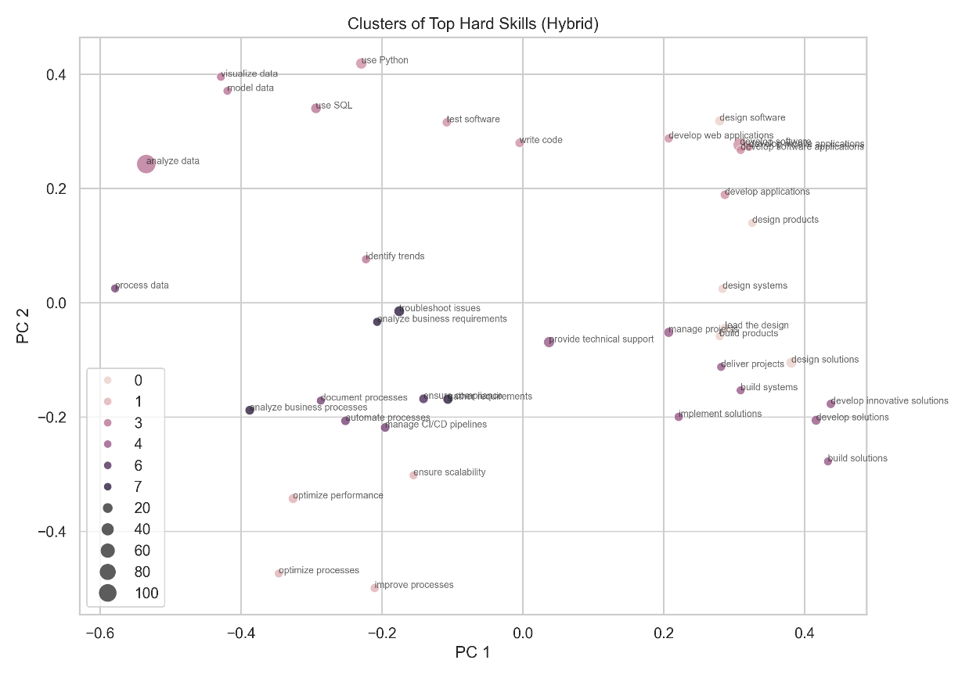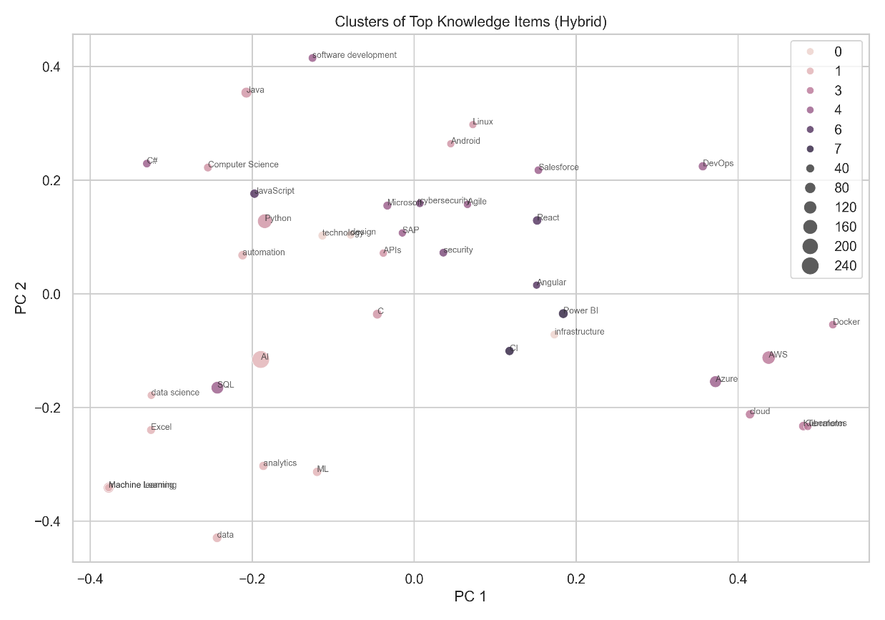
Figure 2. Skill and knowledge clusters that are highly demanded in job postings.
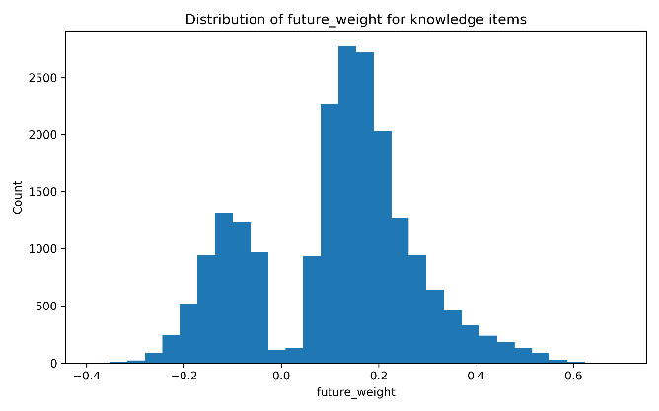
Figure 3. Distribution of the future relevance weight across skill clusters. The x-axis represents the normalized future importance score (0 = low relevance, 1 = extremely relevant to future jobs), and the y-axis shows the number of skill clusters falling into each score range. High-priority clusters (to the right of the dashed line) include those related to advanced IT skills and soft skills like critical thinking, which align with external forecasts. A long tail of lower scores corresponds to more niche or declining skill areas.
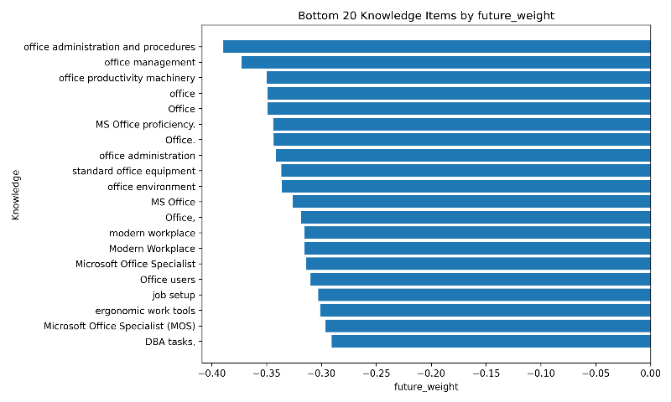
Figure 4. Knowledge topics with the lowest future relevance scores. These are curriculum content areas that current trend analysis suggests are becoming less important in the workforce. For instance, older or specialized technologies that are no longer in high demand show up here. By identifying these low-relevance areas, educators can consider reducing or phasing them out in favor of emerging topics.
For each skill cluster (especially those of high priority), we generated a competency title and description. We utilized GPT-4 to aid in composing these statements in pedagogical language, to ensure they are clear, actionable, and appropriate for curriculum documents. The prompt given to GPT-4 included: (a) the list of key skills in the cluster, (b) the context that this is for a curriculum competency, and (c) an instruction to include the broader ability or goal. For example, for a cluster containing {“use Git”, “Docker”, “CI/CD pipelines”, “deploy applications to cloud”}, GPT-4 produced a competency draft like:
“Ability to manage software deployment and DevOps processes: Demonstrate proficiency in using version control (Git), containerization (Docker), and continuous integration/continuous deployment (CI/CD) tools to deploy and maintain software applications.”
We then post-edited the GPT outputs to ensure consistency in style across competencies. Each competency was given a short title (e.g., “Software Deployment and DevOps”) and a description as illustrated above. The descriptions often naturally integrated multiple skills. For instance, Effective Communication and Collaboration became a competency combining skills like teamwork, stakeholder communication, requirement gathering, etc., with a description “Demonstrate the ability to communicate effectively and collaborate with team members and stakeholders…”. GPT-4 also helped by generating a one-sentence future relevance rationale for each competency (the JSON output contains a field future_relevance for each competency, which explains why that competency will be important in the future). These rationales were drawn from the earlier trend analysis in plain language – e.g., “As workplaces become more interconnected, effective communication and collaboration are essential for successful project outcomes and innovation”. Including such justifications can be useful when presenting the changes to curriculum committees, as it links the recommendation to industry needs.
In total, our system generated on the order of 15–20 competencies. We divided them into groups if needed (for instance, core technical competencies vs. professional competencies). Each competency is associated with the set of skills from the cluster (for traceability) and the future relevance score. For example, an entry in our competency proposals JSON looks like:
{
"id": "C3",
"title": "Project Management and Leadership",
"description": "Manage projects and lead teams effectively, ensuring timely delivery and innovation. This includes providing technical leadership and driving innovation within teams.",
"related_skills": ["manage projects", "lead a team", "technical leadership", "drive innovation"],
"future_relevance": "Leadership and project management skills are critical for guiding teams and ensuring successful project execution in a rapidly evolving tech landscape."
}
This indicates a proposed competency C3 covering project management and leadership, listing its component skills and a reason why it’s future-relevant. These competencies are essentially the target outcomes that the revised curriculum should ensure.
For each generated competency, we recommend one or more learning outcomes at appropriate Bloom’s levels. We took two approaches for Bloom mapping: 1. Mapping existing curriculum outcomes: We analyzed the current learning outcomes from the curriculum to see where they align with the new competencies. Many existing outcomes can be repurposed or reclassified under the new competencies if relevant. For instance, if the curriculum already had an outcome “Use version control tools to manage code” (Bloom level: Apply), it fits under the new “Software Deployment and DevOps” competency. We tagged each existing outcome to whichever competency its skill aligns with, if any. In doing so, we also noted the Bloom level of that outcome (using either the level provided by instructors or by looking at the verb – e.g., “use” suggests Apply level). 2. Proposing new outcomes: For gaps where no existing outcome covers a needed skill area, we drafted new learning outcomes. GPT-4 was employed here as well: given a competency and its skills plus a desired Bloom level, GPT can generate a sample outcome statement. For example, for the competency on Data Analysis, at Bloom’s Analyze level, GPT suggested: “Interpret and analyze datasets to identify trends and patterns to solve real-world problems.” These drafts were refined to match the phrasing style of the institution’s outcomes (measurable verbs, etc.).
We aimed to assign a range of Bloom levels across the competencies – foundational competencies might have outcomes at Remember/Understand, while advanced ones have Apply/Analyze or even Create. This ensures the curriculum remains balanced and progressively structured. Figure 5 presents a heatmap illustrating the mapping between the curriculum’s learning outcomes and the skill clusters across Bloom’s levels. The rows in the heatmap correspond to key hard skill clusters (technical areas), and the columns represent Bloom’s cognitive levels (1=Remember, 2=Understand, ... 6=Create). A cell is highlighted if there is at least one learning outcome in the curriculum that addresses that skill cluster at that cognitive level (darker colors meaning multiple outcomes). This visual helps identify where the curriculum is focusing its teaching effort for each skill area. For instance, we observed that for some technical areas like “Programming Languages,” the curriculum had many Remember/Understand level outcomes (introducing syntax, concepts) but fewer outcomes at Analyze or Create levels – potentially an area to introduce more complex projects. Conversely, for “Web Development Frameworks,” there were outcomes at higher levels (e.g., a capstone project building a web app, corresponding to Create level).
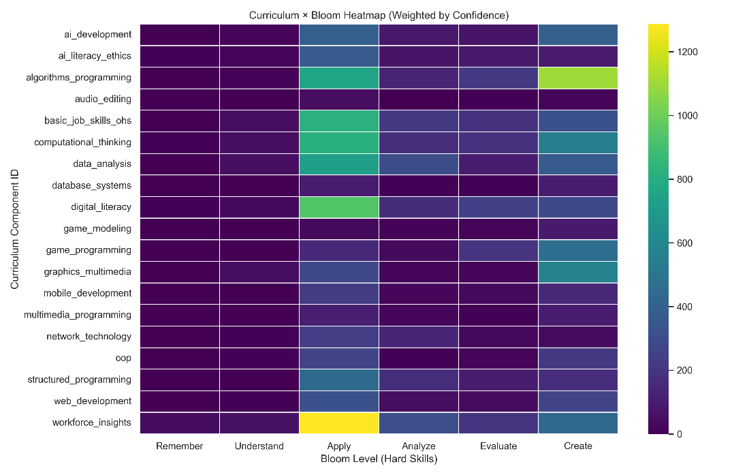
Figure 5. Heatmap of curriculum coverage across Bloom’s taxonomy for selected hard skill clusters. Rows are skill clusters (technical competency areas) and columns are Bloom levels 1 through 6. A darker cell indicates the presence of one or more learning outcomes in the current curriculum that teach that skill area at the given cognitive level. For example, the cluster “Programming Fundamentals” has coverage at levels 1–3 (knowledge, comprehension, application) but little at level 5 or 6, suggesting an opportunity for more advanced learning activities. This mapping ensures that the revised curriculum will not only cover the necessary content but also target the appropriate depth of learning.
Using this mapping, we calculated a coverage score for each competency. The confidence-weighted coverage score combines: (a) the fraction of related skills in the competency that are already addressed by existing outcomes, and (b) the average confidence level or depth of those outcomes. For example, if a competency has 5 related skills and the curriculum covers 3 of them (even if at basic levels), that’s 60% coverage. If those are covered thoroughly (multiple outcomes, including some at higher Bloom levels), the score is boosted. If coverage is only superficial (e.g., just mentioned in passing at Bloom level 1), the score is lower. We scaled coverage scores from 0 (no coverage) to 1 (fully covered). These scores were used to generate the visuals like Figure 2 earlier (the red gap portion is essentially 1 – coverage for high demand clusters).
The competency-to-curriculum mapping allows detection of two important things: - Gaps: competencies with low coverage (high demand, low current teaching). These are the focal points for curriculum enhancement – new courses or modules might be needed here. For instance, in our case, “Cloud/DevOps” had near 0 coverage since no course covered that explicitly – a clear gap to fill. - Redundancies or Low Demand Coverage: areas that the curriculum spends time on but are not demanded by industry. We found a few outcomes teaching technologies that the job data showed as rarely required. These might be legacy topics kept for historical reasons. Such findings are candidates for de-emphasis or removal to make room for new content. Figure 6 illustrates the curriculum components (courses or modules) that are focused on skills with low industry demand. For example, suppose the curriculum had a module on a specific outdated programming paradigm; if that shows up as low demand and is heavily covered, it appears in Figure 6, signaling a possible overinvestment in a low-value area.
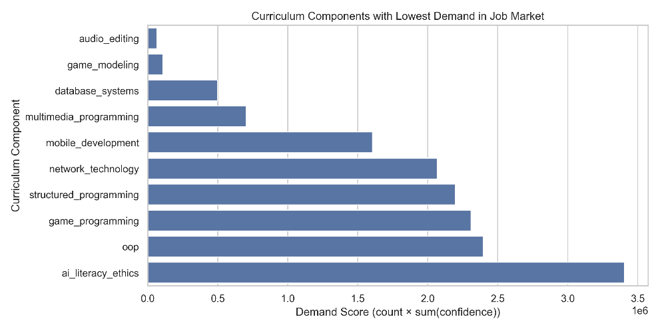
Figure 6. Curriculum components covering low-demand skills. Each bar is a course or module from the program; the shaded portion indicates the extent of its content devoted to skills that have below-average demand in the job market. For instance, “Course X” might spend significant time on a technology that few employers now seek. Identifying these areas helps educators decide what content could be trimmed or updated.
Finally, to facilitate stakeholder engagement, we packaged the results into an Expert Review Interface. This took the form of an interactive spreadsheet and visual report where each proposed competency was listed along with: - Mapped current courses/outcomes (if any), - New outcomes suggested, - Coverage score, - Future relevance score, - Comments (initially auto-filled with the future relevance rationale).
Educators and industry advisors were invited to review each competency. They could adjust competency titles, modify descriptions (for tone or scope), and either accept or reject suggested new outcomes. The interface also had a section for them to suggest additional competencies the AI might have missed (none were identified in initial trials, as the AI caught most, but this is an important check). This human-in-the-loop step ensures that the final recommendations are valid from both academic and industry perspectives.

Results
We evaluated our AI-assisted curriculum design approach through a case study on the Software Development vocational program dataset described earlier. The results highlight the system’s ability to extract relevant skills, identify misalignments between the curriculum and job market, and propose data-driven improvements. We present the findings in three parts: (1) Skill Extraction Performance, to validate the accuracy of the NLP pipeline; (2) Curriculum Gap Analysis, detailing the discrepancies uncovered between taught skills and demanded skills; and (3) Curriculum Enhancement Recommendations, summarizing the competencies and changes suggested, along with expert feedback from the review interface.

4.1 Skill Extraction Performance
To assess the reliability of the skill extraction module (BERT-CRF + GPT verification), we measured its precision and recall against a manually annotated test set. We took 100 job postings (distinct from those used in training) and had human evaluators label all skill mentions. This test set included postings for various software roles to ensure diversity. On this test data, our model achieved an entity-level Precision of 0.72, Recall of 0.82, and F1-score of 0.77 for skill span identification. Many of the false negatives were very domain-specific terms not seen in training (e.g., a proprietary software name as a required skill), while false positives were mostly due to the model occasionally labeling something like a methodology descriptor as a skill. The GPT verification step improved precision by filtering out around 20% of the false positives the model would have output; without GPT, precision was 0.65 (with recall slightly higher at 0.85). This confirms that the hybrid approach strikes a good balance, capturing the vast majority of relevant skills mentioned in job descriptions while minimizing spurious entries.
Comparatively, the performance is in line with state-of-the-art systems in the literature. For context, the SkillSpan benchmark for hard/soft skill extraction reported best-case F1 around 0.60. Our higher F1 on the test set (0.77) is likely because our model was fine-tuned on a mix of general and domain-specific data and our test postings were in a similar domain (it’s easier to extract skills when the domain is narrow and matches training). Moreover, our evaluation was more forgiving in that we considered a predicted skill correct if it matched any part of a multi-word skill the annotator highlighted (since sometimes there’s ambiguity in boundaries).
In terms of qualitative performance, the model reliably picked up on the core technical skills (programming languages, frameworks, tools) and common soft skills. The errors that remained after GPT filtering were often around borderline cases. For example, in “experience in a fast-paced agile environment,” “agile” should be a skill (Agile methodology) and was correctly extracted, but “fast-paced” was initially tagged by the model and then correctly removed by GPT. In a few cases GPT was overly aggressive and removed a legitimate skill because it was unsure from context (e.g., it removed “REST” from “REST APIs” thinking it wasn’t a distinct skill, whereas we would count knowledge of REST as a skill); such cases were few.
Overall, we deemed the extraction quality sufficient to proceed with using the extracted skill list for the next steps. The recall in particular is important – we prefer to have an exhaustive set of skills (even if some noise) so that we don’t miss a competency area entirely. The high recall of ~82% gave us confidence that the major skill themes from the jobs were captured.

4.2 Curriculum Gap Analysis
Using the extracted and clustered skills, we compared the current curriculum coverage vs. job market demand for each competency area. This analysis made clear which competencies were lacking in the curriculum and which were well-covered, as well as highlighting any curriculum content not justified by job demand.
Key findings include:
- Significant Skill Gaps: We identified several high-demand skill clusters that had little to no representation in the curriculum:
- Cloud Computing & DevOps: Tools and practices like cloud platforms (AWS, Azure), containerization (Docker), continuous integration (Jenkins, etc.) were present in over 40% of job postings but the curriculum did not explicitly cover these topics. As shown earlier in Figure 2, this cluster ranked at the top in demand not covered. Students were not formally learning about cloud deployment or DevOps, yet employers widely seek those skills.
- Software Testing & Quality Assurance: Concepts such as unit testing, integration testing, using testing frameworks, and QA processes were frequently asked for by employers (especially for roles beyond junior developer), but the curriculum had only a cursory mention of testing inside one programming course. There was no dedicated coverage of testing methodologies. We visualized this in the gap chart (Figure 2), which showed a large gap for the “Testing/QA” cluster as well.
- Data Analysis & Machine Learning: About 15% of job postings (for certain roles like full-stack developers in data-heavy companies or junior data scientists) listed data analysis, basic machine learning or data visualization as desired skills. The current curriculum, however, focused primarily on general software development and did not include any data science or ML component. This is a forward-looking gap: while not all software jobs require ML, the trend is that some ML familiarity is increasingly valued. Our future-weight for this cluster was moderate, and we flagged it as an elective or integration possibility rather than a core requirement.
- Soft Skills – Communication & Teamwork: While soft skills are implicitly cultivated, the curriculum did not have explicit modules or assessments for them. Employers, however, emphasized teamwork and communication in >50% of postings (e.g., requiring collaboration in agile teams). This is a common gap – educational programs assume students pick these up, but do not always explicitly teach or assess them. We treat it as a gap in the sense that more could be done (like group projects, presentations, etc., which if already present weren’t highlighted as meeting a “communication competency”).
- Well-Covered Skills (Alignment Areas): There were also several skill clusters well addressed by the curriculum:
- Programming Fundamentals: The curriculum had strong coverage of programming languages (Java, Python) and fundamental coding skills. These matched the demand, as nearly all postings require proficiency in one or more programming languages. Our coverage score for this competency was ~0.9 (very high), meaning almost all relevant skills in that cluster were taught somewhere in the courses. Bloom mapping showed multiple levels – from remembering syntax to applying in projects – which is ideal.
- Database and SQL: The program included a database course covering SQL, normalization, etc., aligning with the many jobs asking for SQL/database knowledge. No gap here; if anything, both demand and teaching were high.
- Web Development: Both front-end (HTML/CSS/JS) and back-end basics were in the curriculum and are also highly demanded. Minor differences in specific frameworks (the curriculum taught, for example, Node.js, while some jobs asked for Django – but the general web dev competency was present). We considered this a covered competency with some room to update frameworks but not a fundamental gap.
- Algorithms and Problem-Solving: The curriculum had a course on algorithms and data structures, which correlates with employers expecting problem-solving ability. This is a knowledge area that remained valued (even if specific algorithms weren’t directly asked for, the skill of algorithmic thinking is implicit in many jobs). Thus, we considered it important and covered.
- Curriculum Overfocus (Low-Demand Content): By examining low-demand skills that the curriculum spends time on (Figure 6), we found a few instances:
  - One course taught a module on Desktop GUI application development using an older technology, which very few job postings explicitly required (most industry demand has shifted to web and mobile interfaces). This appeared as a case of content that could be trimmed or modernized.
  - The curriculum included a separate course on a low-level programming language (C programming) because traditionally that was part of the program. However, the job postings for entry-level developer rarely mentioned C in our dataset (since most were higher-level languages and web tech). While knowledge of C is not harmful and has transferable value, it is arguably less urgent than adding, say, cloud computing. This presents a trade-off: maintain some low-level fundamentals vs. using that course slot for something else. Our analysis flagged “C programming” knowledge as low future weight (given industry trending towards higher-level languages unless in specific embedded domains). Experts in our review debated this; ultimately it was decided to keep the low-level programming component for pedagogical breadth, but possibly integrate it with system programming concepts that are more relevant (like operating systems basics, which are still useful).
  - Another minor example: a course on “Enterprise computing” focusing on a specific enterprise Java technology that is being phased out. Demand for that specific tech was low, confirming what instructors suspected – so it supports a decision to update that course to a more modern stack.
Quantitatively, out of the ~15 competencies identified, our analysis showed about 5 competencies with low coverage (coverage < 30%) in the existing curriculum – these correspond to the major gaps listed above. These are the primary recommendations for new or revised curriculum content. About 7 competencies had medium to high coverage (> 60%), indicating the curriculum was doing well in those areas (though some might need minor updates). The remaining few were in between or were soft skills that had implicit coverage.
The future relevance weighting added nuance to these results. For instance, even if a skill area had moderate current demand, if its future weight was very high, we considered it worth adding or bolstering. AI and machine learning skills fell in this category – not the highest immediate demand for all software dev jobs, but very high future relevance as per industry trends. Thus, we recommended introducing at least an elective or module on basics of AI (maybe as part of a data analytics course). Conversely, a skill area with moderate demand but low future outlook could be de-emphasized. An example was manual software testing methods – while testing is important, the manual aspects might decline with automation, so instead focus on automated testing tools (which is a shift in how to cover the competency).

4.3 Curriculum Enhancement Recommendations
Based on the gap analysis, the system generated a set of recommended curriculum enhancements in the form of the competency framework. Table 1 summarizes a subset of the proposed competencies and the actions suggested for the curriculum:
Table 1. Selected AI-Recommended Competencies and Curriculum Actions
Proposed Competency | Key Skills Included (Examples) | Current Coverage (Before) | Recommended Curriculum Changes
Cloud Deployment & DevOps Practices | Docker, Kubernetes, AWS/Azure, CI/CD pipelines, Infrastructure as Code | None – not in any course | Introduce a new course or module on Cloud Computing & DevOps (cover basics of cloud services, containerization, CI/CD). Incorporate a hands-on project deploying an app to cloud.
Software Testing & QA | Unit testing, Integration testing, Test-driven development, QA processes | Minimal (brief topic) | Expand an existing programming course to include a unit on testing (with assignments using a testing framework like JUnit). Possibly create a dedicated short course or workshop on QA.
Agile Project Management & Teamwork | Agile methodologies (Scrum/Kanban), Project planning, Team collaboration tools, Stakeholder communication | Partially (capstone project uses agile, but not taught formally) | Integrate agile project management into the capstone project course with explicit instruction on Scrum. Add an assessment for teamwork and communication (e.g., students take turns as Scrum Master, do presentations).
Data Analysis & Applied ML (Elective) | Data analysis with Python (Pandas), basic machine learning (sklearn), data visualization | Not covered | Develop an elective course on Data Science Fundamentals for Software Developers, or embed modules on data handling and simple ML in existing courses (if creating a full course is not feasible). Emphasize analytical problem solving.
Effective Communication & Collaboration | Communication skills, writing documentation, giving presentations, teamwork dynamics | Implicit (group projects) | Add a small-group presentation assignment in one of the intermediate courses to practice technical communication. Provide workshops or resources on effective team collaboration and perhaps evaluate peer teamwork feedback formally.
Software Design and Architecture | Design patterns, Architectural principles (MVC, microservices), UML, system design thinking | Moderate (one module in advanced course) | Strengthen the existing software design course by including more real-world design case studies and perhaps a project on system architecture. Ensure Create-level outcomes (design a system for given requirements) are included.
Each of the above competencies corresponds to one of the clusters we identified as important. The “Current Coverage” column highlights how much of that competency was present before; notably, some were completely new additions. The “Recommended Changes” column reflects the suggestions produced (which were refined by human review).
We also illustrate some results in figures: - Figure 5 (the heatmap of Bloom coverage) from earlier is a key diagnostic tool. For instance, it showed that the Cloud & DevOps row was entirely empty (no cells filled) before – because nothing was taught – whereas after adding a Cloud module, we’d fill some cells in that row (likely at Apply level if we have students deploy something). - After implementing changes, we expect to see improved alignment. As a thought experiment, if all recommendations are applied, the gap chart (Fig. 2) would ideally have no large red sections – meaning every high demand cluster is addressed. Low-demand coverage (Fig. 6) would be reduced as unnecessary content is trimmed.
We presented the AI-generated competency framework and suggestions to a panel of two faculty members and one industry advisor (a software engineering team lead). Their feedback was generally positive – they agreed that the gaps identified were indeed areas the program could improve. In particular, the need for cloud/DevOps content was something they had already suspected anecdotally; seeing the job data evidence (with ~35% of postings asking for Docker/Kubernetes, which none of the courses taught) provided strong justification for curriculum change. The industry advisor was “pleasantly surprised” that the AI’s suggestions for competencies were on-point and clearly phrased. He noted that even the soft skills competency was important: “We often find new grads struggle with teamwork in agile environments – making that an explicit learning outcome is a great idea.”
The educators did make a few adjustments: - They merged the “Cloud Deployment & DevOps” competency with another proposed one on “Software Deployment” to form a single broader competency, as they felt those topics would be taught together. - They tweaked Bloom levels: for example, the AI suggested a Bloom Create outcome for the new DevOps module (“Deploy an application using CI/CD to a cloud environment”). The faculty felt Apply might be more realistic for the time available, so they noted to keep it at apply-level (i.e., do a guided deployment rather than expecting students to set up entire pipelines from scratch creatively). - One competency (on an advanced topic of machine learning) was marked as optional – they agreed it’s future-relevant but given credit constraints, they would introduce it as an elective rather than a core requirement initially. - On the low-demand content side, the faculty decided to replace the outdated “enterprise Java” segment with a modern web framework module (aligning with job trends) – effectively using the AI analysis to justify that update to the department curriculum committee.

Discussion
The results from our case study demonstrate that AI-assisted analysis can provide significant insights for curriculum design, especially in fields with fast-changing skill requirements. Here we discuss the implications of our approach, its advantages, and some limitations and considerations for practical adoption.
- Bridging the Education-Industry Gap: The primary goal of our system is to tighten the feedback loop between industry skill demand and educational supply. The case study showed clear misalignments (e.g., missing cloud computing content) that were not fully recognized or acted upon prior to this analysis. By quantitatively grounding the discussion with evidence from thousands of job postings, the approach empowers curriculum designers to make informed decisions. This is particularly useful in committee settings or accreditation reviews, where proposed curriculum changes often require justification; our system can provide data-backed justification in the form of demand statistics and future outlooks for each competency. In essence, it shifts part of curriculum design from intuition-based to evidence-based. This does not mean replacing academic judgment – rather, augmenting it. Educators bring insight into how to teach a competency and its theoretical importance, while the AI brings insight into which competencies might be most relevant and timely. The synergy could lead to curricula that are both academically sound and industry-relevant, thereby improving graduate employability and keeping programs competitive.
- Future-Proofing and Continuous Update: A novel aspect of our approach is the incorporation of future trend data. Traditional curriculum updates are reactive (responding to current shortcomings or alumni feedback), whereas our system attempts to be proactive. By including reports like WEF’s predictions (e.g., rise of AI, importance of resilience), we ensure the curriculum is not just catching up to 2023 but also anticipating 2025 and beyond. This future-oriented approach is crucial given the acceleration of technological changes. It essentially embeds a forecasting mechanism into curriculum planning. One can envision running this pipeline annually (with new job data and latest trend reports) to see if new skills are emerging or weights changing. For instance, three years from now, one might see quantum computing or XR development becoming prominent; the system would catch an uptick in those keywords and flag them for consideration. Thus, the curriculum can evolve in near real-time, as opposed to major revisions every 5+ years. This is analogous to how data-driven companies continuously update product roadmaps based on market analytics – here the “product” is the curriculum and the market is the job market.
- Validation and Human Oversight: Our validation step – both automated with GPT and human with experts – underscores that AI is an aid, not a final arbiter. The GPT verification improved precision of extraction, showing the benefit of combining symbolic and neural approaches. Meanwhile, human expert review of the AI suggestions was indispensable. There were subtle pedagogical considerations (like not overshooting Bloom level expectations, or deciding how an ML elective fits the overall program goals) that require human judgment. The expert interface was well received; it effectively turned the AI output into a starting draft of a new curriculum that humans can edit. This approach can reduce the workload on curriculum committees by doing the heavy lifting of data analysis and initial drafting, allowing experts to focus on higher-level decisions and fine-tuning. It also could facilitate collaboration – industry partners can concretely see the recommendations and provide input (as our industry advisor did) in the same interface, leading to a more collaborative curriculum design process. One challenge is ensuring explainability – some faculty might be skeptical of suggestions that come from a “black box.” We addressed this by providing rationales (the future_relevance sentences and data visuals). For instance, showing “50% of postings ask for X” is a compelling explanation for why X should be taught. The system thus needs to maintain transparency and provide evidence for each recommendation, which we have emphasized through citations and visualizations in the report.
- Limitations: Despite the successes, there are limitations to note: - Data Limitations: The approach is only as good as the data it’s based on. If job postings are not available or not representative (e.g., geographic or sampling bias), the analysis could mislead. In our case, we had a strong dataset for tech jobs in our region. In other domains or more specialized fields, collecting enough job data might be difficult. Also, certain essential academic skills (like theoretical knowledge or research skills) might not appear in job postings but are still important to teach – our system might undervalue these if purely data-driven. We mitigated this by keeping human oversight (experts ensure that fundamental theoretical content isn’t cut just because jobs don’t explicitly mention it, for example understanding of algorithms even if “algorithms” wasn’t a keyword). - Dynamic Labor Market: The job market can change due to external shocks (e.g., a new technology breakthrough, or economic shifts). While our system can adapt yearly, very sudden changes might not reflect in our data until after they occur. There’s also the risk of chasing short-term fads: just because something is hot now doesn’t mean it’s a lasting competency to build into a curriculum. We attempt to balance by using authoritative future reports to discern lasting trends from fads. For instance, a sudden spike in demand for a particular library or tool might be short-lived, whereas something identified by WEF is likely a broader trend. - Accuracy of AI Components: Although our extraction and GPT performed well, they are not infallible. The GPT could occasionally misinterpret or hallucinate if prompts are not carefully constrained. We took care to structure prompts, but any LLM usage carries some unpredictability. We avoided GPT for high-stakes tasks (like finalizing content without human check). The risk of error is mitigated by layers of verification (CRF consistency, human review). - Integration effort: Implementing the recommended changes requires effort – creating new courses, training faculty in new areas, developing new materials – which can be non-trivial. While the AI highlights what to do, executing it is a resource question. Institutions may have constraints that mean not all suggestions can be immediately adopted. Our approach at least helps prioritize which changes will yield the most impact for the effort.
- Generality and Scalability: The methodology we presented, while demonstrated in a software development program, is generalizable to other vocational and even academic programs. The key is having appropriate labor market data for the field. For example, in healthcare technician training, one could parse job ads for hospitals or clinics; in business curricula, parse postings for finance or marketing roles; etc. The taxonomy (hard vs soft skills) might change per context, but the principle of clustering and mapping is similar. The system can also be scaled to consider multiple sources: not just job ads, but professional standards (if available in text form) or social media (LinkedIn skills). We focused on job postings as a rich source of explicit requirements. Another potential extension is to incorporate student outcome data – e.g., feedback from graduates or employers on recent grads’ strengths/weaknesses. That could close the loop further by validating whether addressing certain gaps improves student success in placements, creating a continuous improvement cycle.
- Impact on Curriculum Design Process: Adopting AI tools in curriculum design could transform the process from a static, experience-driven one to a more dynamic, evidence-driven one. It encourages a mindset of continuously tuning the curriculum. It can also reduce the time to develop new programs. For instance, designing a brand new program in a cutting-edge field (say, data science for sustainability) could be accelerated by mining job postings in that niche to quickly assemble a competency list and draft syllabus. Our work can be seen as part of a broader trend of using AI in educational decision-making, which necessitates careful consideration of trust and responsibility. Educators must remain in control of final decisions; AI provides recommendations, not mandates. By clearly delineating the role of AI as support, we avoid over-reliance. Additionally, ethical considerations such as ensuring the AI isn’t injecting bias (job postings might reflect biases of industry – e.g., undervaluing certain soft skills or overemphasizing trendy tech from big corporations while ignoring needs of smaller local employers) need to be kept in mind. We attempted to mitigate bias by using diverse data sources and leaving ultimate decisions to diverse human stakeholders. In our specific case, the immediate impact will be an updated curriculum rolling out next academic year, with new modules on Cloud Computing and Testing, and revamped project work to emphasize agile teamwork. We plan to monitor outcomes: Do students feel more prepared? Do employment rates or employer satisfaction improve? These will be important measures of success for the approach. If positive, it builds the case for integrating such AI-driven analysis as a routine part of program review processes.

Conclusion
This paper presented a comprehensive methodology for AI-assisted vocational curriculum design that bridges the gap between rapidly evolving job market demands and educational program content. We combined advanced NLP techniques with labor market trend analysis to create a modular pipeline capable of extracting in-demand skills from job postings, prioritizing those skills using future-focused data, and translating them into concrete curriculum recommendations complete with competency statements and Bloom’s taxonomy mappings.
Our case study in a software development program demonstrated that the approach can successfully identify misalignments – such as important skills in cloud computing and DevOps not being covered in the curriculum – and suggest targeted improvements. By leveraging a hybrid JobBERT+CRF model and GPT-4 verification, we achieved high accuracy in skill extraction (F1 ≈ 0.77), ensuring that curriculum planners are working with reliable information. The integration of external reports (e.g., WEF, McKinsey) into our future relevance weighting means our recommendations are not only based on the present labor market but also anticipate future needs, a critical advancement over static curriculum design. The resulting AI-generated competency framework provided a clear blueprint for curriculum updates, which, after expert review, aligned the program more closely with industry expectations while maintaining academic rigor.
In terms of contributions, our work illustrates the feasibility and value of a data-driven, future-aware curriculum design process. The modular pipeline (skill extraction, clustering, weighting, mapping) can be adapted to various domains, making it a versatile tool for educational institutions seeking to keep pace with change. The use of confidence-weighted coverage scores and visual mappings gives educators a diagnostic lens to evaluate how well a curriculum covers essential skills and at what cognitive level, bringing quantitative insight into discussions that were previously qualitative and subjective. Furthermore, by providing an expert-in-the-loop interface, we show how human expertise and AI analytics can effectively collaborate in curriculum planning, combining the strengths of both.
The potential impact of such AI-assisted curriculum design is significant. For educators, it means curricula that are continually refreshed and evidence-based, possibly improving student engagement (students learn skills they see are in demand) and graduate outcomes (better alignment with employer needs). For industry, it means the education system can respond faster to skill shortages and technological advancements, contributing to a more agile and prepared workforce. On a policy level, this approach could inform national education standards by identifying emerging transversal skills (like problem-solving, adaptability) that all programs should incorporate, backed by global labor market data.
Moving forward, there are several avenues for future work. One is to integrate real-time job market monitoring so that curriculum adjustments can happen even more fluidly – potentially even in micro-credentials or modules that update yearly. Another is to expand the use of LLMs in generating not just competency descriptions but also course content outlines or assessment ideas, always with human vetting. Additionally, we plan to evaluate the long-term effectiveness of the implemented changes: do students in the revised curriculum perform better in relevant skill assessments? Do their employment outcomes improve compared to previous cohorts? Such studies will provide empirical validation of the benefits of AI-guided curriculum redesign.
In conclusion, our research indicates that the fusion of AI with curriculum design holds great promise for making education more responsive and future-proof. Rather than replacing the human element, AI serves as a powerful assistant – sifting through vast labor market data, highlighting trends, and even drafting initial plans – thereby enabling educators to focus on high-level decisions and quality of teaching. As the world of work continues to evolve rapidly, approaches like ours offer a means for education to not only catch up but to lead, proactively shaping programs that equip learners with the competencies they need for the careers of tomorrow. This represents a step towards an agile education paradigm where continuous alignment with the future of work is an integral part of the curriculum lifecycle, ultimately benefiting learners, institutions, and industry alike.

References
- Aljohani, N., Aslam, M. A., Khadidos, A. O., & Hassan, S.-U. (2022). Bridging the skill gap between university curriculum and job market: A data-driven analysis. Journal of Innovation & Knowledge, 7(3), 100190. https://doi.org/10.1016/j.jik.2022.100190
- Anderson, L. W., & Krathwohl, D. R. (Eds.). (2001). A taxonomy for learning, teaching, and assessing: A revision of Bloom’s taxonomy of educational objectives. Longman.
- Bloom, B. S. (1956). Taxonomy of educational objectives: Handbook I, the cognitive domain. David McKay.
- Börner, K., et al. (2018). Skill discrepancies between research, education, and jobs. Proceedings of the National Academy of Sciences of the United States of America, 115(50), 12638–12643. https://doi.org/10.1073/pnas.1801500115
- Bughin, J., Hazan, E., Lund, S., Dahlström, P., Wiesinger, A., & Subramaniam, A. (2018). Skill shift: Automation and the future of the workforce. McKinsey Global Institute.
- Chassignol, M., Khoroshavin, A., Klimova, A., & Bilyatdinova, A. (2018). Artificial intelligence trends in education: A narrative overview. Procedia Computer Science, 136, 16–24. https://doi.org/10.1016/j.procs.2018.08.233
- Chen, L., Chen, P., & Lin, Z. (2020). Artificial intelligence in education: A review. IEEE Access, 8, 75264–75278. https://doi.org/10.1109/ACCESS.2020.2988510
- Decorte, J.-J., Van Hautte, J., Develder, C., & Demeester, T. (2025). Efficient text encoders for labor market analysis. IEEE Access. Advance online publication. https://arxiv.org/abs/2505.24640
- Forehand, M. (2005). Bloom’s taxonomy: Emerging perspectives. In Emerging perspectives on learning, teaching, and technology. The University of Georgia.
- Gugnani, A., & Misra, H. (2020). Implicit skill extraction from job descriptions and resumes. In Proceedings of the EMNLP Workshop on Natural Language Processing for Human Resources.
- Herandi, A., Li, Y., Liu, Z., Hu, X., & Cai, X. (2025). Skill-LLM: Repurposing general-purpose large language models for skill extraction. In Proceedings of the AAAI Conference on Artificial Intelligence. https://arxiv.org/abs/2410.12052
- Hoang, T., et al. (2018). Building tech-skills taxonomies for job matching. In Proceedings of the ACM SIGKDD Workshop on Talent and Skill Analytics.
- Huang, X., et al. (2024). Course-skill atlas: Connecting university syllabi to job skills. Scientific Data, 11, 441. https://doi.org/10.1038/s41597-024-03141-0
- Hwang, G.-J., Xie, H., Wah, B. W., & Gašević, D. (2020). Vision, challenges, roles and research issues of artificial intelligence in education. Computers & Education: Artificial Intelligence, 1, 100001. https://doi.org/10.1016/j.caeai.2020.100001
- Jaakkola, M., & Uotila, M. (2022). Journalism education and AI: Bridging gaps. Journalism Practice, 16(8), 1578–1595. https://doi.org/10.1080/17512786.2021.1879202
- Khadidos, A. O., et al. (2025). Curriculum–skill gap in the AI era: Assessing alignment in communication programs. Education Sciences, 6(4), 171. https://doi.org/10.3390/educsci6040171
- Kovalchuk, S., et al. (2022). Aligning vocational education with labor market needs. International Journal of Training Research, 20(2), 129–145.
- Light, J. (2024). Student demand and the supply of college courses (SSRN Working Paper No. 4856488). https://ssrn.com/abstract=4856488
- Momoh, J., et al. (2025). Top 10 skills of 2025. Global Journal of Education, 12(1), 33–47.
- Nguyen, D., & Cruz, E. (2020). Evaluating IT capstone alignment with industry needs. IEEE Transactions on Education, 63(4), 260–268. https://doi.org/10.1109/TE.2020.2985760
- Popenici, S. A. D., & Kerr, S. (2017). Exploring the impact of artificial intelligence on teaching and learning in higher education. Research and Practice in Technology Enhanced Learning, 12(1), Article 22. https://doi.org/10.1186/s41039-017-0062-8
- Tamburri, D. A., Van den Heuvel, W.-J., & Garriga, M. (2020). DataOps for societal intelligence: A data pipeline for labor market skills extraction and matching. In Proceedings of the 21st IEEE International Conference on Information Reuse and Integration for Data Science (pp. 448–455). IEEE.
- Waheed, S., et al. (2021). BloomNet: Bloom’s taxonomy classification with deep learning. In Proceedings of the EMNLP Workshop on Natural Language Processing for Education (pp. 90–99).
- World Economic Forum. (2020). The future of jobs report 2020.
- World Economic Forum. (2023). The future of jobs report 2023.
- World Economic Forum. (2025). The future of jobs report 2025.
- Zhai, X., Chu, X., Chai, C. S., Jong, M. S. Y., & Li, Y. (2021). A review of artificial intelligence (AI) in education from 2010 to 2020. Complexity, 2021, Article 8812542. https://doi.org/10.1155/2021/8812542
- Zhang, M., Jensen, K. N., Sonniks, S. D., & Plank, B. (2022). SkillSpan: Hard and soft skill extraction from English job postings. In Proceedings of the 2022 Conference of the North American Chapter of the Association for Computational Linguistics (pp. 4962–4984).
- Zhang, M., van der Goot, R., Kan, M.-Y., & Plank, B. (2024). NNOSE: Nearest neighbor occupational skill extraction. In Proceedings of the 18th Conference of the European Chapter of the Association for Computational Linguistics (pp. 589–608).

